User Guide for Online examination file submission system

*November 2022*



Table of Contents

Document Revisions 3

Introduction 4

Scope and Purpose 4

Quick Start Guide 4

The Online examination file submission system Home screen 4

The Online examination file submission system User selection screen 5

The Online examination file submission system Login screen 6

Student Dashboard 7

Lecturer Dashboard 9

Lecturer Exam Viewer 10

Exam Department Dashboard 11

Exam Department Exam Schedule Uploader 12

Index 14

# Document Revisions

|  |  |  |
| --- | --- | --- |
| Date | Version Number | Document Changes |
| 06/10/2022 | 0.1 | Initial Draft |
| 10/10/2022 | 0.2 | Revised |
| 20/10/2022 | 1.0 | Published |
| 26/10/2022 | 1.1 | Revised (Mobile addition) |
|  |  |  |
|  |  |  |
|  |  |  |
|  |  |  |
|  |  |  |

# Introduction

## Scope and Purpose

* Introduce the practical project and its purpose.
* Highlighting key features and benefits.
* Introduce the purpose of the user guide.
* The documentation also contains smartphone screens. These screens work on the same concept as the Desktop website screens.

## Quick Start Guide

### The Online examination file submission system Home screen

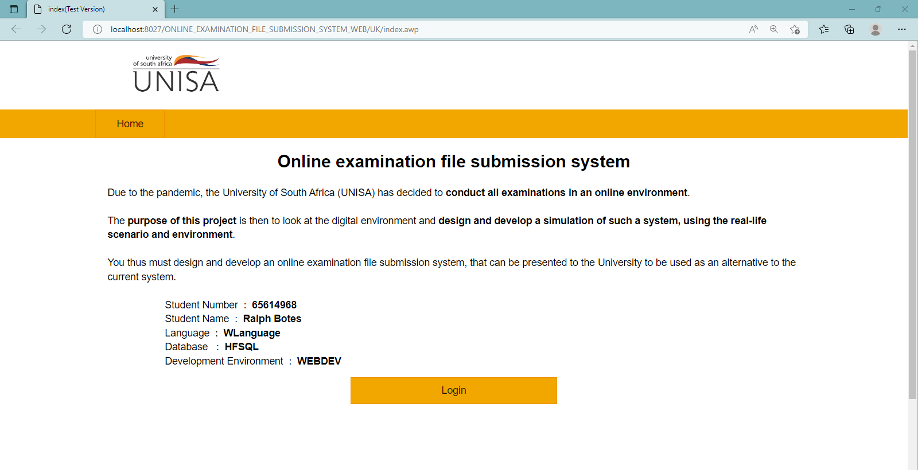

Select Logo or tab to access home page from anywhere

Redirects to a secured login intranet site

#### General Process

The first page that opens when the site URL is accessed. This is where a general description and information is added along with a login button that if selected, accesses the UNISA intranet site from the internet site page. This is to allow for better security.

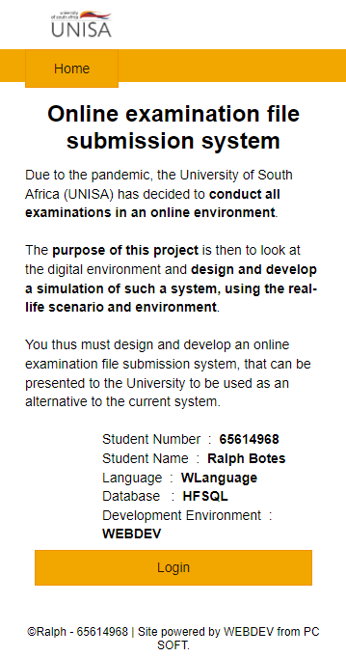

### The Online examination file submission system User selection screen

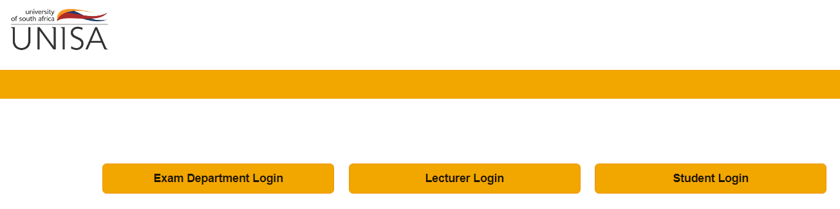

Select the user type to open login for that user

#### General Process

The Login selection page allows a user to select which login they require. Authentication allows Students to only enter the student section, Lecturers to enter the Lector sections and so on.



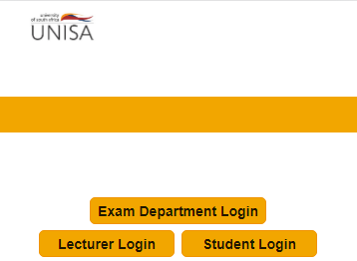

### The Online examination file submission system Login screen

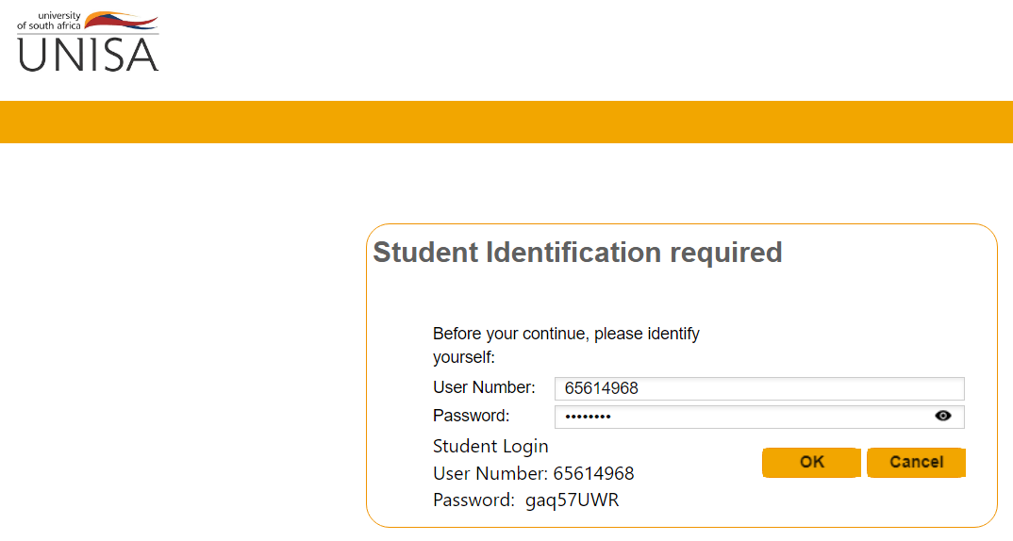

Enter user credentials and press “OK” to validate

#### General Process

After the user has been selected, the user authentication screen opens which allows the user to enter credentials and validate to acquire access if they do have the required permission.



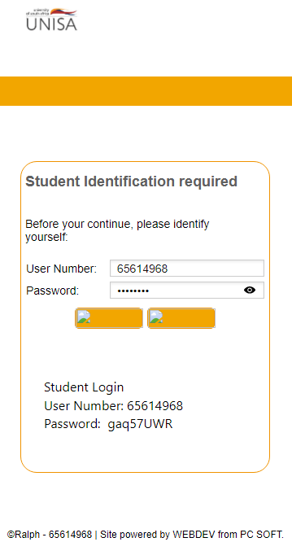

### Student Dashboard

The Online examination file submission system Student Dashboard

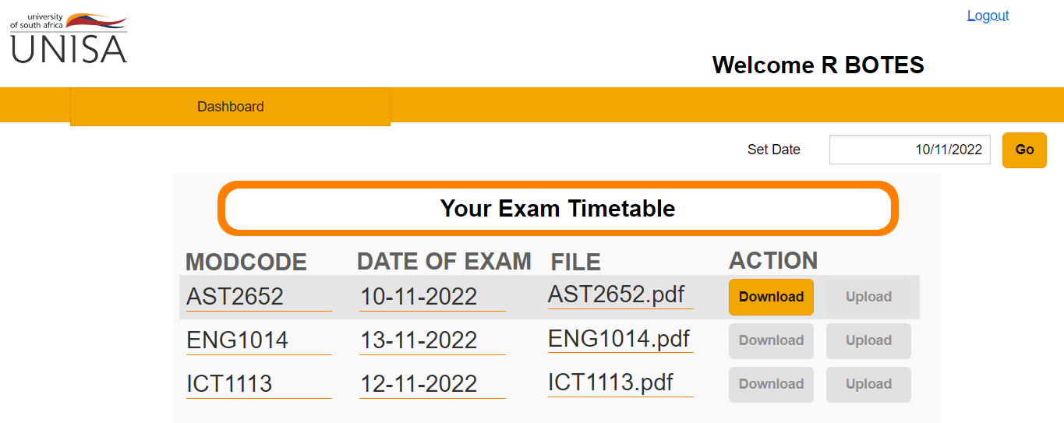

Active user

Simple logout

Enabled and disabled action buttons to allow user to handle tasks at given times.

Modules student is registered for

Tabs related to different pages accessible by user

#### General Process

After the successful login of a Student user, the student dashboard is displayed. Here the student can view all the modules they are registered for along with exam dates.



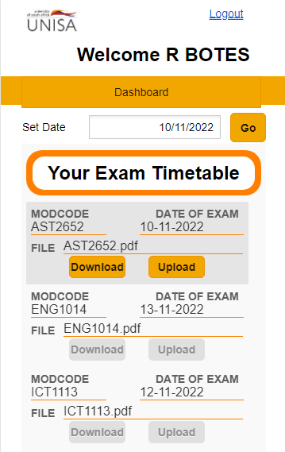

#### Exam day Process

If the module exam date corresponds to the current day, and the time is between 9:00 and 14:00, then the Download button is enabled to allow the student to download the exam.

When the download button is pressed, a popup message is displayed indicating to the student that if they continue the download, then the exam timer will start if it has not already.

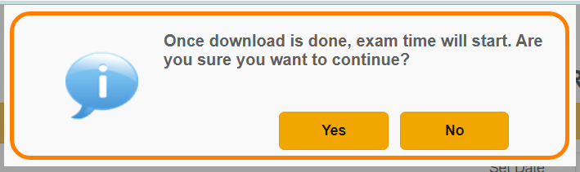

The Upload button then enables and the student then has 2 hours to do the exam and submit it.

If time runs out, the Upload button will disable and the student won’t be able to submit their exam.

**Remark:** If the timer is already active when the page is accessed, then both the Download, and Upload buttons will be enabled when the Student is still well in the required timeframe.

The student exam file uploaded is checked and validated to be of .PDF type, and is automatically renamed to the appropriate naming schema for the file and placed in the correct directory in the JRouter.

### Lecturer Dashboard

The Online examination file submission system Lecturer Dashboard

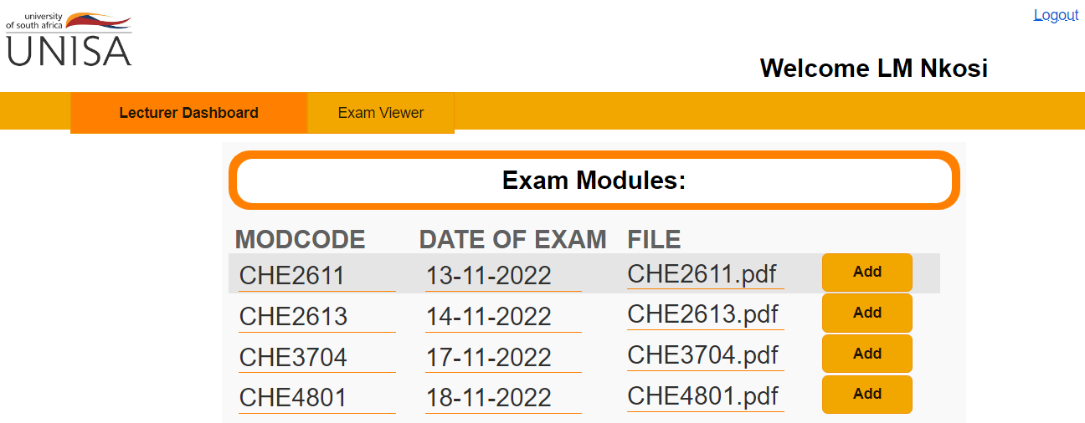

Tabs related to different pages accessible by user

Active user

Action buttons to allow user to handle tasks

Modules Lecturer is registered for

Simple logout

#### General Process

After successful Lecturer login, the Lecturer dashboard is displayed. Here the lecturer can upload or update exam papers on the site directory, as well as view submissions from students after the exam has completed.

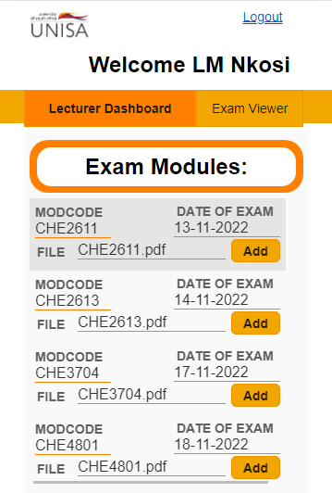

#### Exam Upload Process

If the Add button is selected next to one of the modules the lecturer has access to, then the file explorer window opens that allows the user to select an exam from their directory and upload it to the exam file in the directory. The file is also automatically named accordingly.

**Remark:** Exam dates are preset by the exam department.

### Lecturer Exam Viewer

The Online examination file submission system Lecturer Exam Viewer

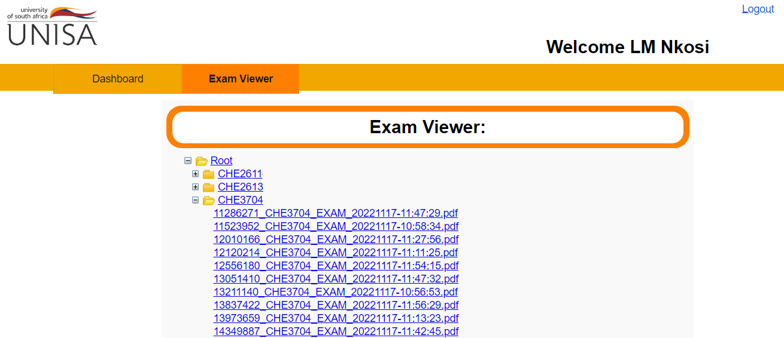

Treeview of readable modules and the exams submitted

Active user

Simple logout

Tabs related to different pages accessible by user

#### General Process

The Exam viewer page consists of a TreeView of the modules the Lecturer is permitted to access. Each module contains the exam .PDF documents uploaded by students. When a document is selected, a browser pdf viewer opens that allows the Lector to view only the selected document. Documents are only visible after exam has ended for that module.

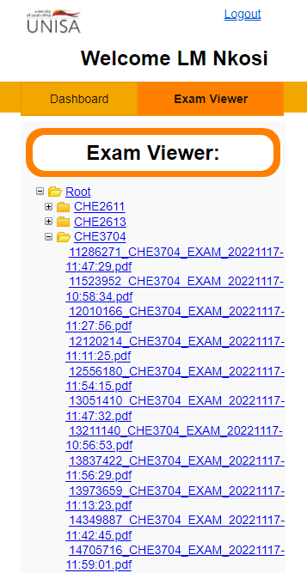

### Exam Department Dashboard

The Online examination file submission system Lecturer Exam Viewer

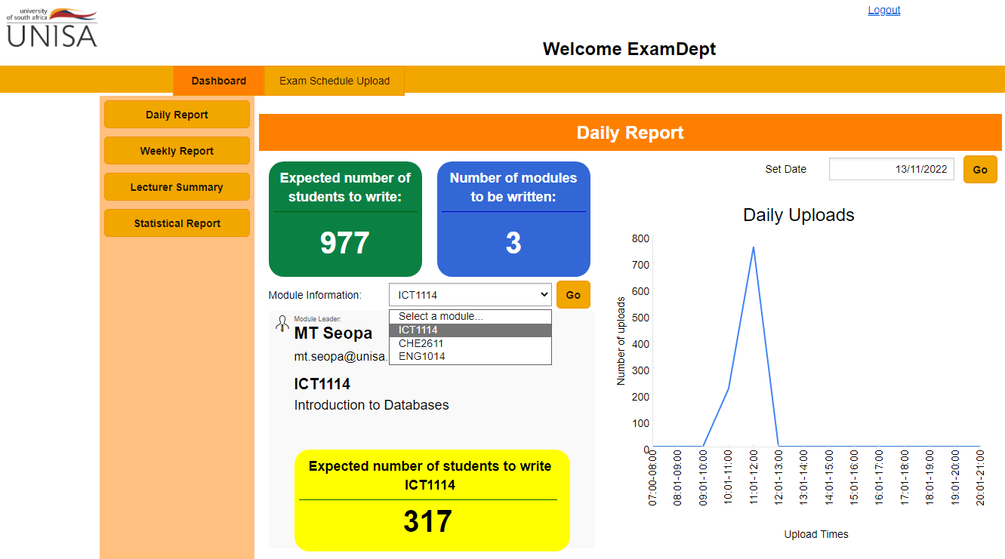

Active user

Written module dropdown selection

Uploads Chart

Details viewer

Side bar with MIS Report tabs

Tabs related to different pages accessible by user

Simple logout

#### General Process

The Exam Department can use the sidebar to filter through 4 different MIS Reports in reference to the data collected during exams as well as other related information.

Responsive GUI’s are used to create a more active information viewer.



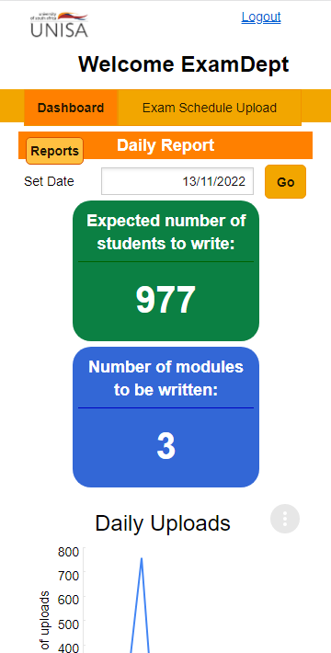

### Exam Department Exam Schedule Uploader

The Online examination file submission system Schedule Uploader

Simple logout

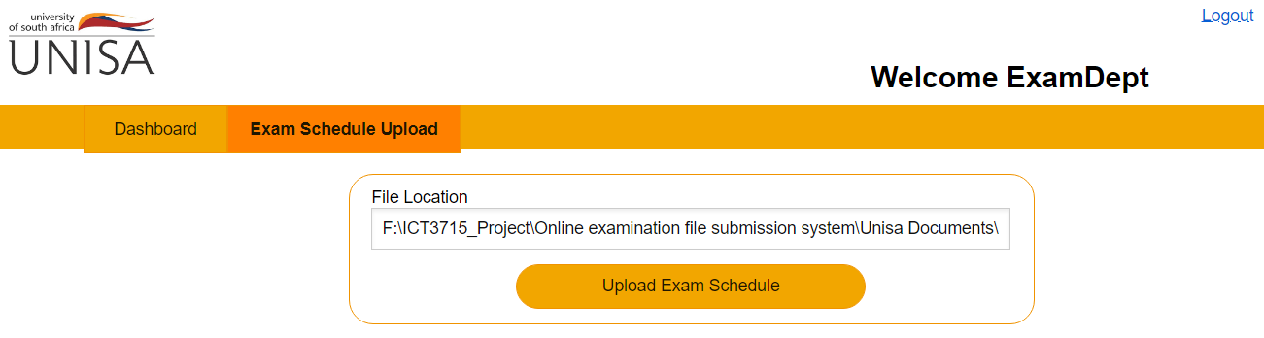

Schedule uploader

Tabs related to different pages accessible by user

Active user

#### General Process

A directory path is supplied to the location of the Exam schedule .CSV document with the following layout:

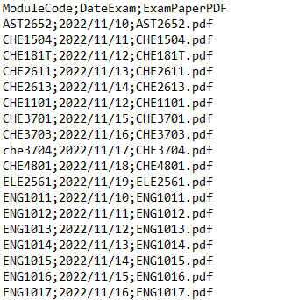

Then when the Upload button is selected, the new exam dates are uploaded and either added or updated in the database.



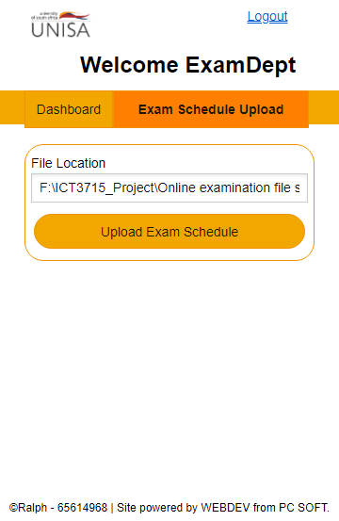

# Index

Exam Download, 6

Exam schedule, 10

Exam time run-out, 6

Exam timer start, 6

Exam Upload, 6

Home screen, 4

Lecturer Dashboard, 7

Lecturer Exam Viewer, 9

Login selection, 5

MIS Reports, 9

Module and exams TreeView, 8

Student Dashboard, 6

UNISA intranet site access, 4

upload or update exam papers, 7

user authentication, 5

view submissions, 7